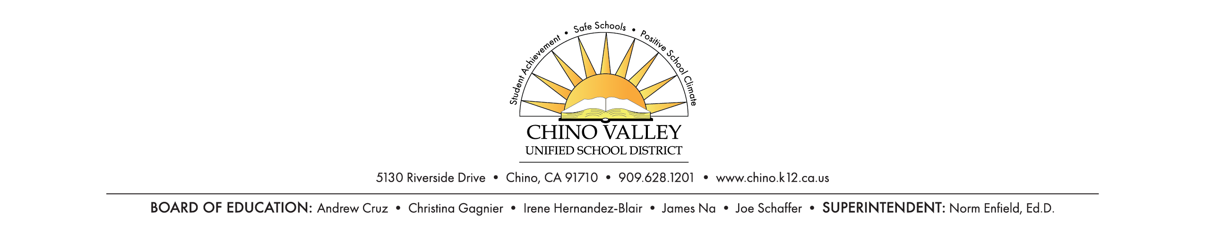

**PRESS RELEASE**

**FOR IMMEDIATE RELEASE CONTACT:** Imee Perius, (909) 628-1201 ext. 1616

January 10, 2020 [imee_perius@chino.k12.ca.us](mailto:imee_perius@chino.k12.ca.us) or

Andi Johnston, (909) 628-1201 ext. 1617

[andrea_johnston@chino.k12.ca.us](mailto:andrea_johnston@chino.k12.ca.us)

**Chino Valley Unified School District to Host its Second Parent Information Forum**

*Parents will learn about mental health resources, drug abuse trends, and social media issues.*

Chino, CA – On Wednesday, January 22, 2020, parents and guardians will meet in the Multipurpose Room at Chino Hills High School, located at 16150 Pomona Rincon Road in Chino Hills, for the second CVUSD Parent Information Forum of the 2019-2020 school year. The event will begin at 6:30 pm following a light dinner served at 5:45 pm..

The event provides resources and information on trends and issues facing today’s students. School Resource Officers and District professionals will be on hand to present and answer questions. Childcare services will be provided so parents, caregivers, and guardians can attend the forum. Translation services will also be available for Spanish speakers.

The spring Suicide Prevention Awareness Forum will take place on February 5, 2020 at 6:30 pm at Chino High School in Chino. More information will be disseminated as the spring date approaches.

***About Chino Valley Unified School District:***

Founded in 1860, Chino Valley Unified School District serves approximately 27,000 students across 35 schools within the Chino Valley area. Home to 18 California Distinguished schools, students receive a rigorous, 21st century education in preparation for college and career. Thriving performing arts and athletic programs, nationally recognized marching bands and engaging parent-school partnerships distinguish Chino Valley Unified School District as one of the best school districts in California. For more information about Chino Valley Unified School district, please visit [www.chino.k12.ca.us](http://www.chino.k12.ca.us).

###